Luke Evans

March 7th, 2021

Lab 6 – Public Key Infrastructure

*Task 1: Becoming a Certificate Authority (CA)*

First, we copy the conf template to our working directory and edit the base directory:

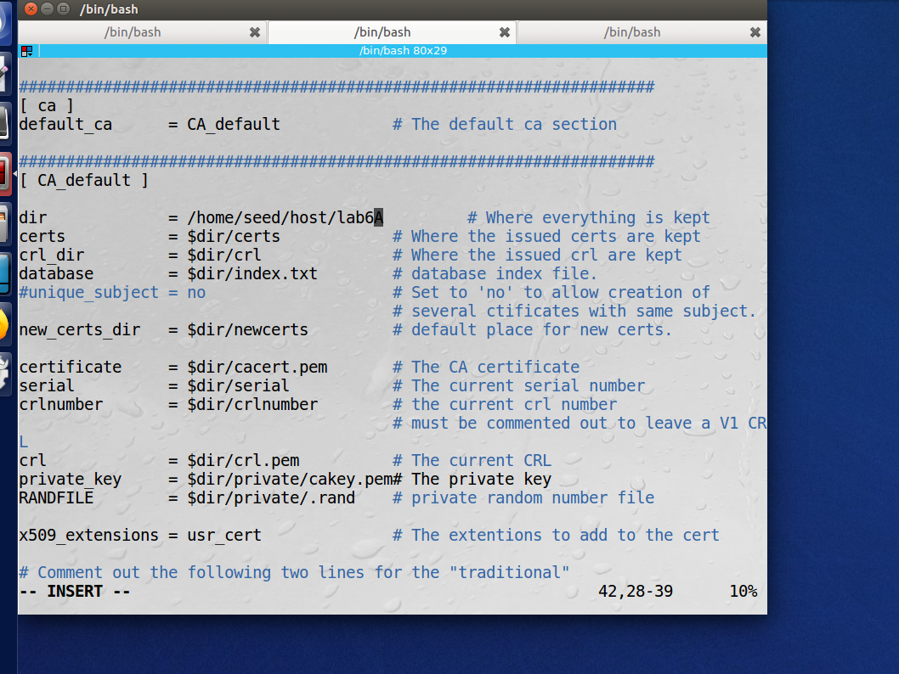

Next, I created the necessary directories and files:

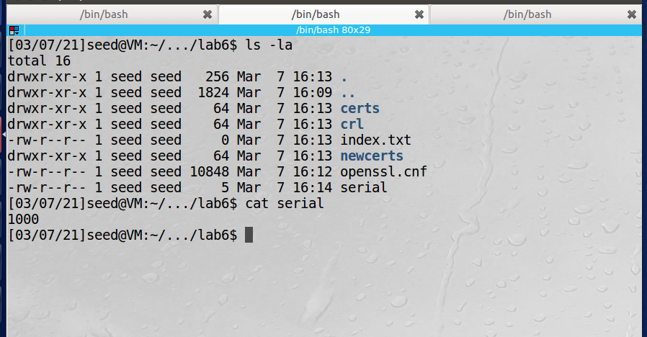

Next we generate a self signed certificate. Password is security:

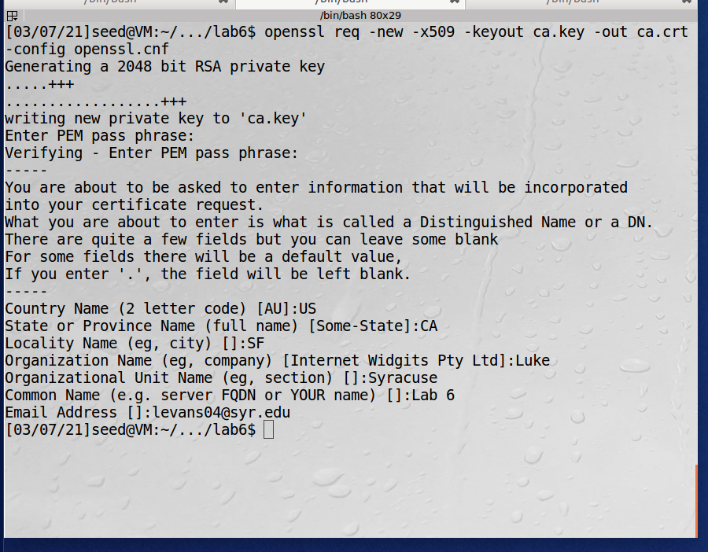

Observation: In this task we made ourselves a certificate authority and created a self signed certificate. We had to copy over the openssl.conf file and add the necessary directory structure. Then we used an openssl command to generate our x509 certificate with a password of security.

Explanation: Certificates are required for public key encryption and to be trusted they must be signed by a trusted source known as a certificate authority (CA). The CA vouches for certificates that the CA signs for. For demonstration purposes we created our own CA so that we did not have to pay to accomplish these lab tasks.

*Task 2: Creating a Certificate for SEEDPKILab2020.com*

*Step 1: Generate Public/Private Key Pair*

*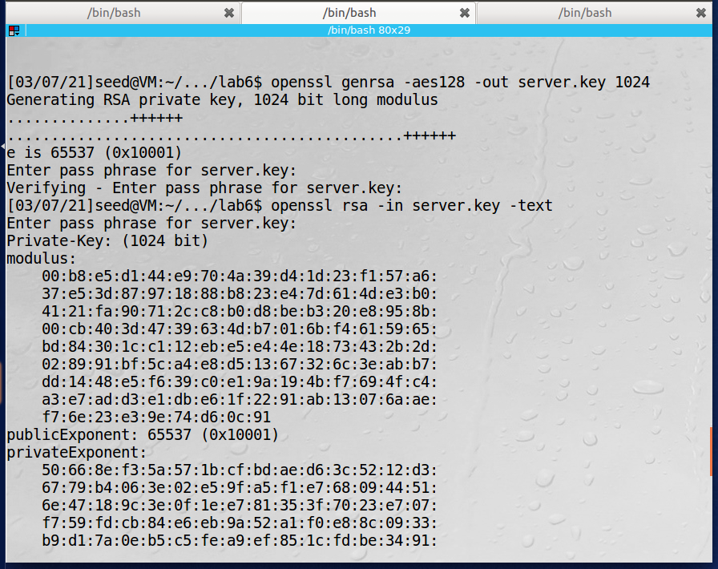*

*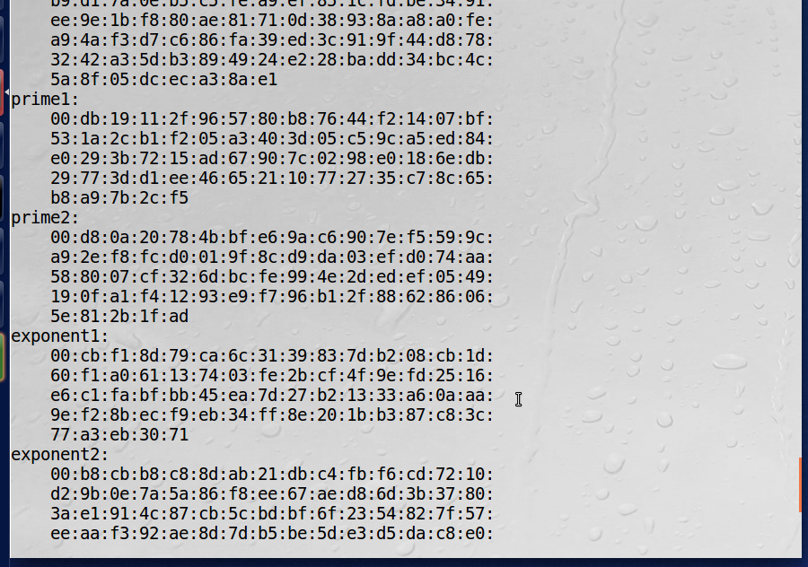*

*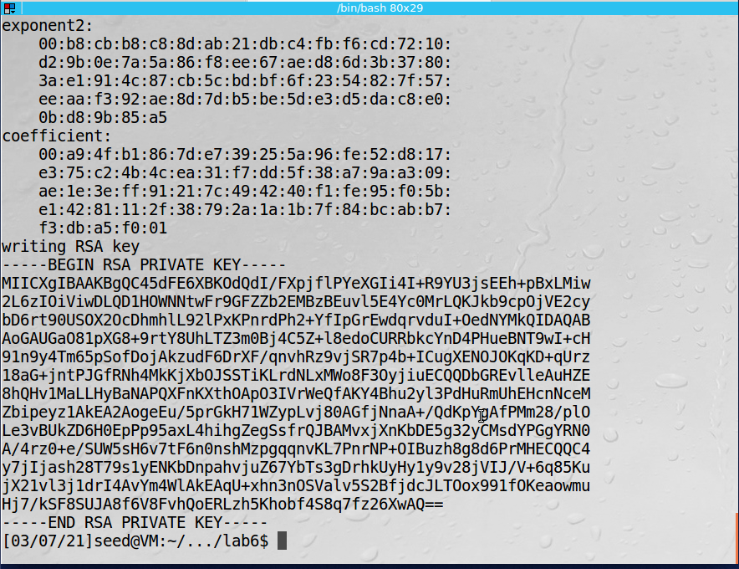*

Step 2: Generate a Certificate Signing Request (CSR)

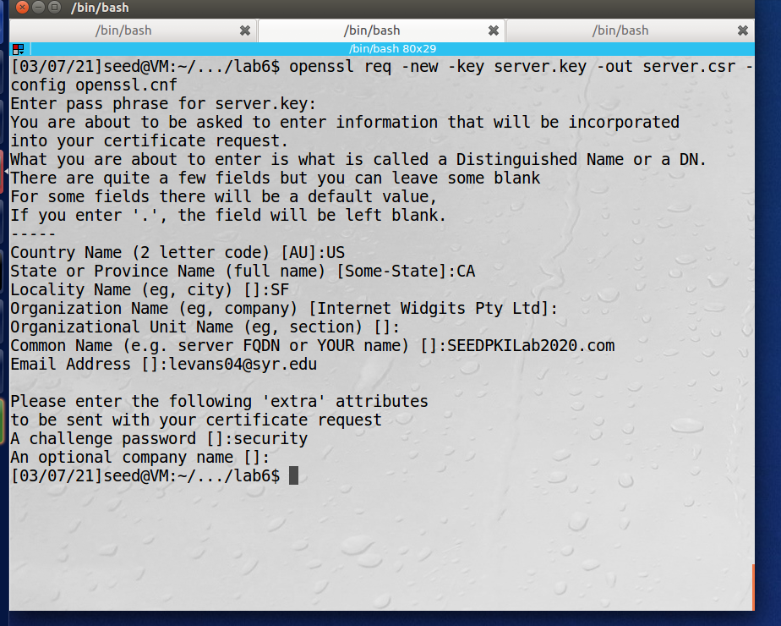

Step 3: Generating Certificates:

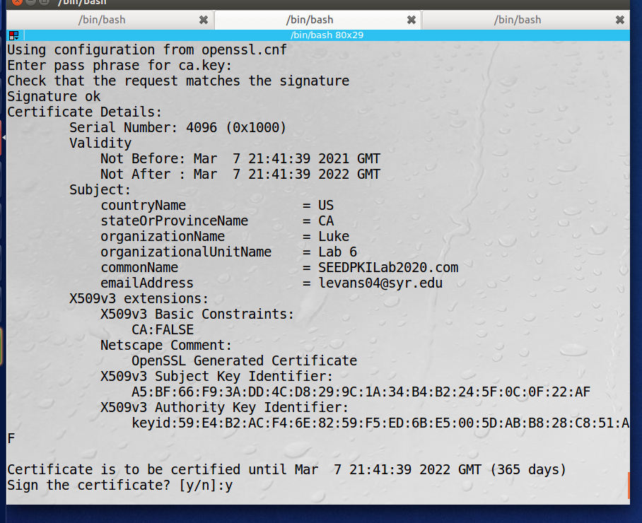

This is our signed pem file:

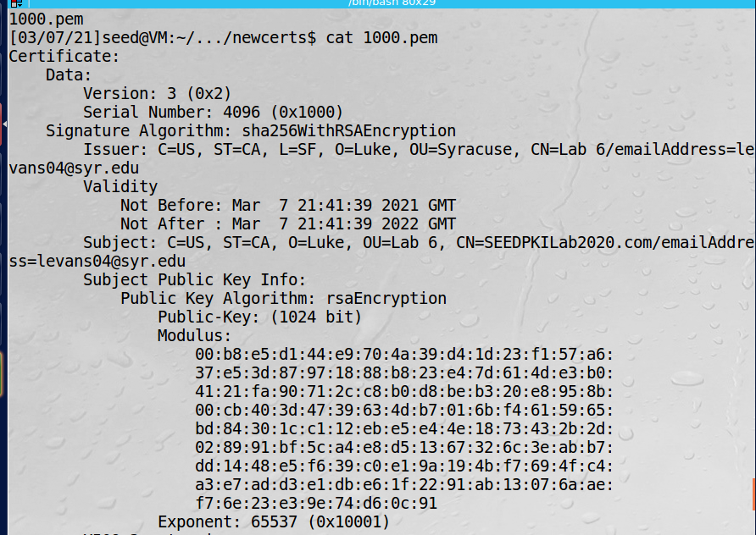

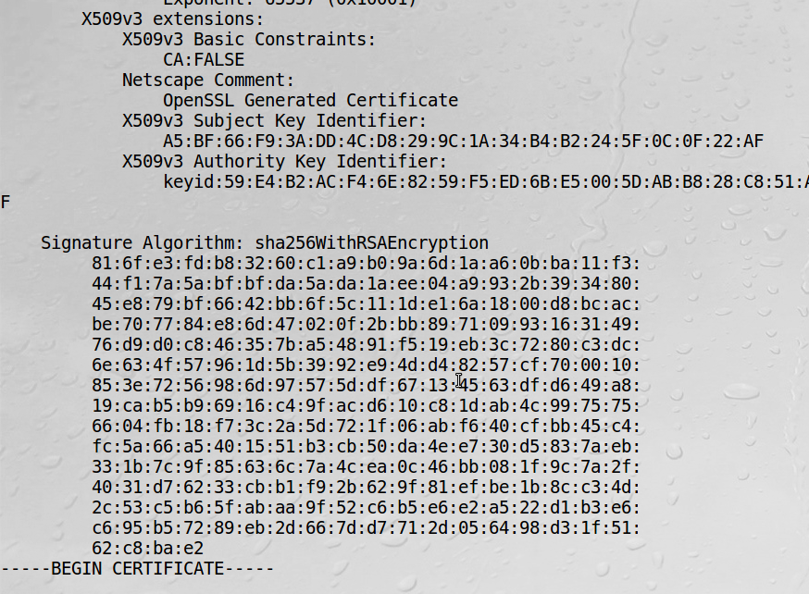

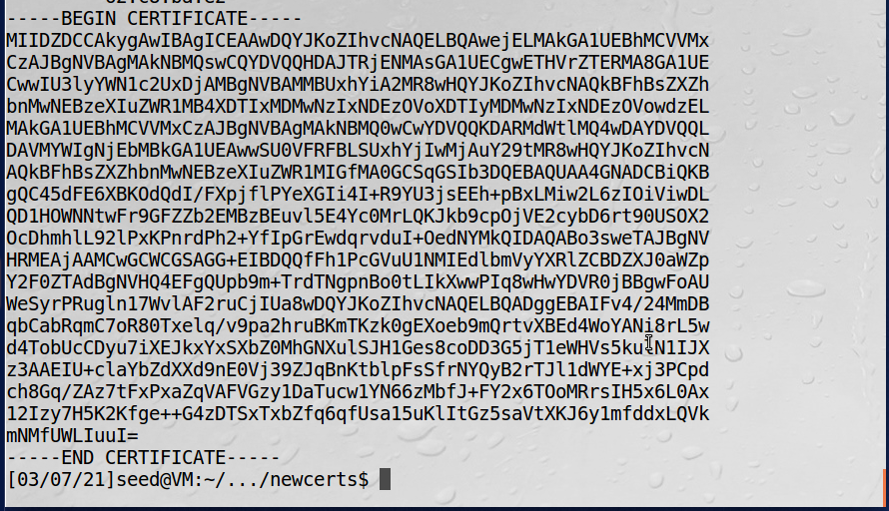

Observation: In this task we created our public private key pair. Then we were able to create a certificate signing request that included our public key. Generally we would give this .csr file to a CA and they would sign it for us but since we created our own root CA we signed the certificate ourselves.

Explanation: The process for generating a valid certificate involves three steps. First a pub/private key pair must be created, then a csr is generated containing the public key, then the csr is signed by a CA. This allows a chain of trust to be established.

*Task 3: Deploying a Certificate in a HTTPS Webserver:*

Step 1: Update /etc/hosts file:

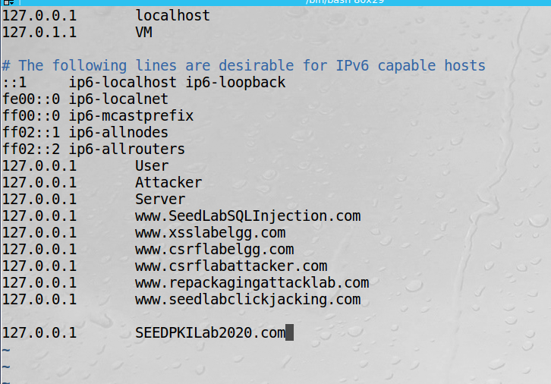

Step 2: Configure the Webserver

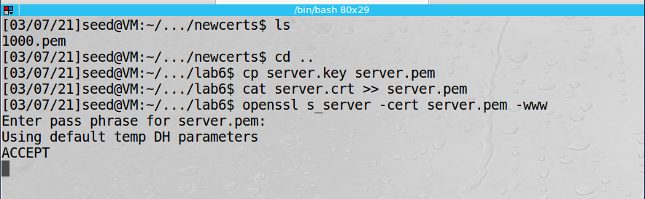

Step 3: Getting Browser to Accept our CA:

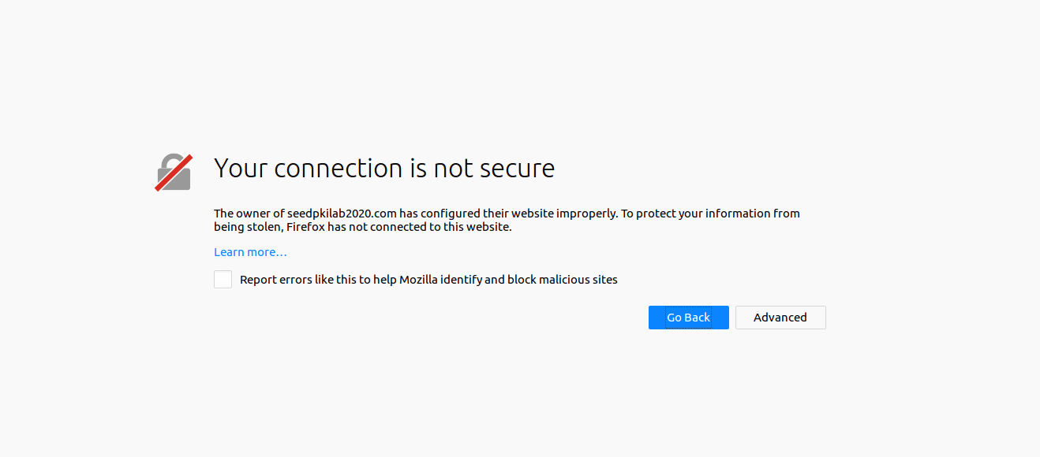

After import our ca.crt file into firefox we are able to view the site over https:

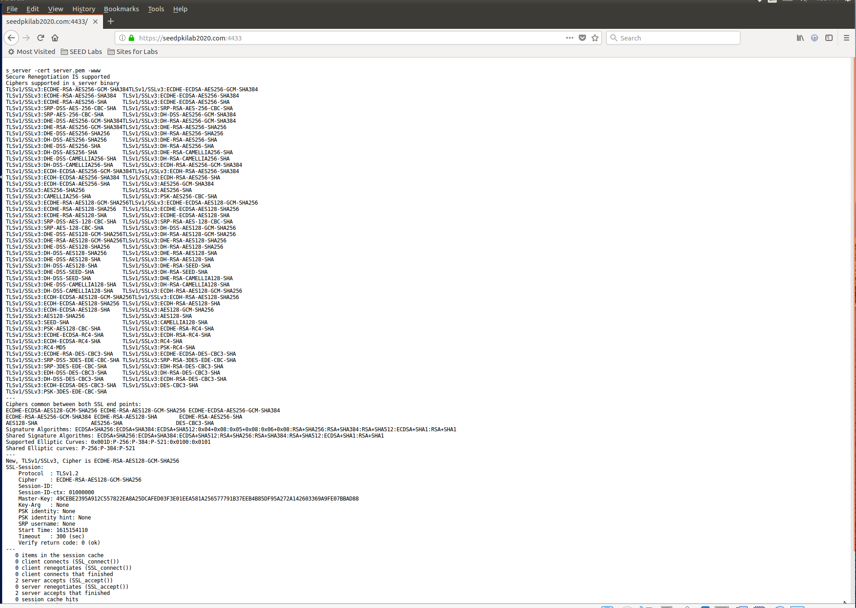

Next we will modify 1 byte in our server.pem file, below is the file prior to our change:

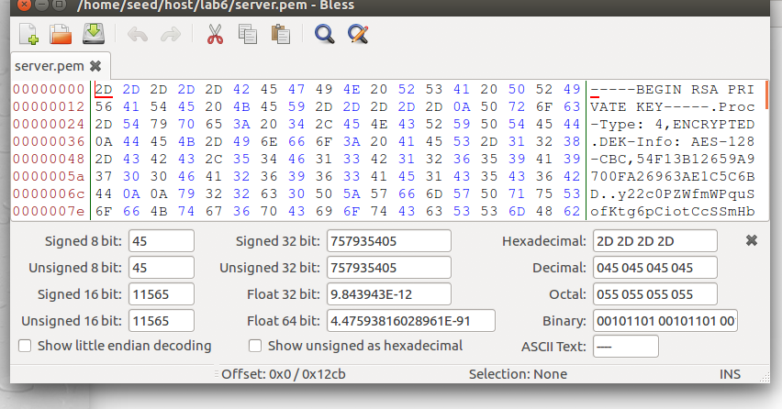

We change a byte for 2D to AA:

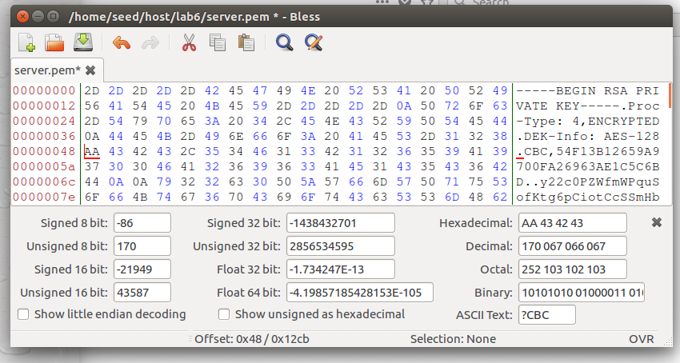

The server resuses to start:

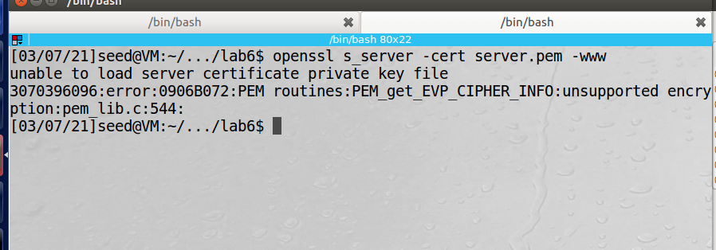

We change the byte back and we can restart our server:

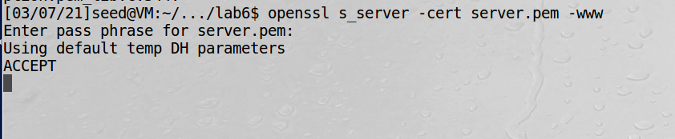

Then we corrupt a different byte:

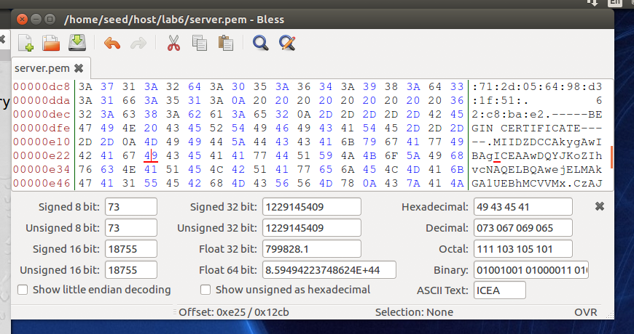

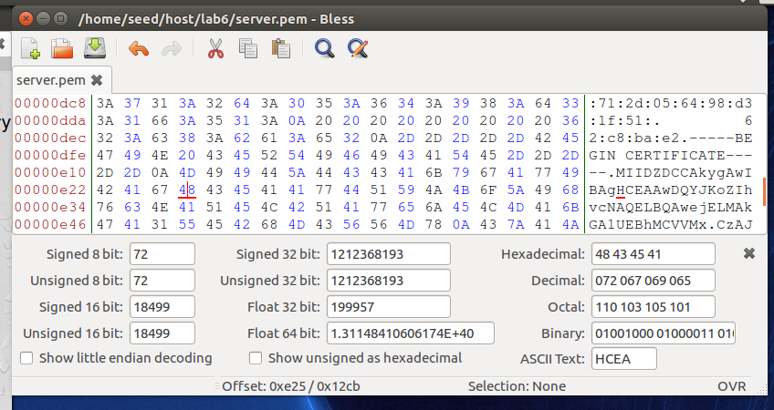

Cannot start server so we must choose a different place. We change 74 to 75 and then restart the server:

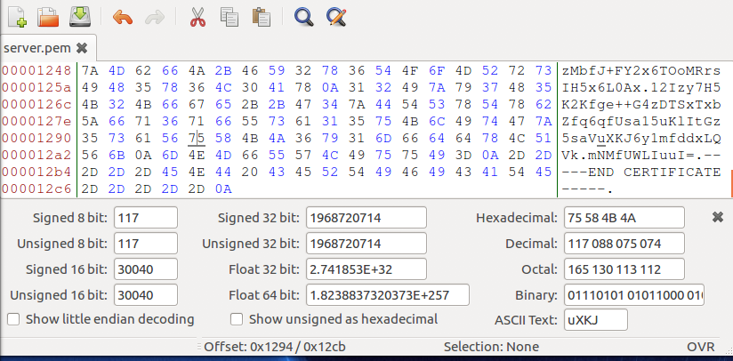

Now when we restart our server the connection is no longer secure:

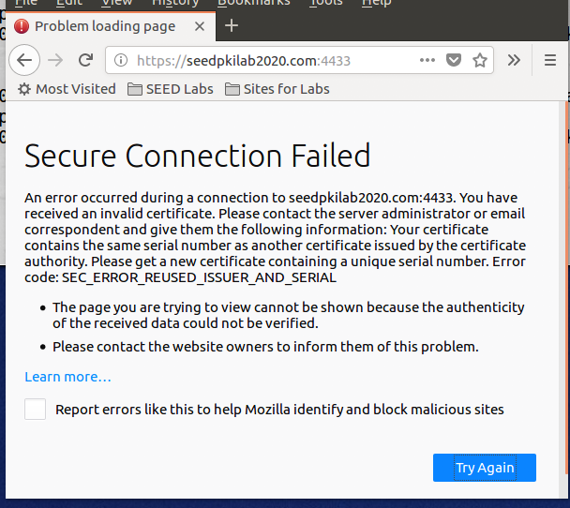

If we attempt to navigate to <https://localhost:4433> we get an unsecure connection because our certificates common name does not match:

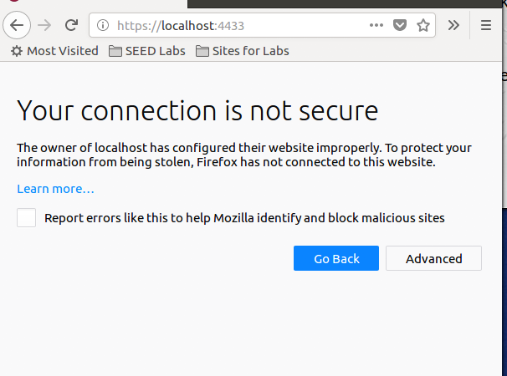

Observations: In this task we route traffic from <https://seedpkilab2020.com> to our loopback IP of 127.0.0.1 by adding an entry to the /etc/hosts file. Then we load our certificate into our simple openssl server and add it to the accepted CA trust list in firefox. When we do this correctly we are able to establish a secure connection. When we corrupt the file, the connection is no longer secure.

Explanations: Properly deploying the certificate to our webserver allowed us to connect via https. In order for this to work, we had to tell firefox to trust the CA we created otherwise anyone could do this to spoof their certificates. When certificates are configured properly then the data portion of the message will be encrypted by TLS.

*Task 4: Deploying the Certificate in an Apache-Based HTTPS Website:*

We have to modify the default-ssl.conf file to tell it about our website:

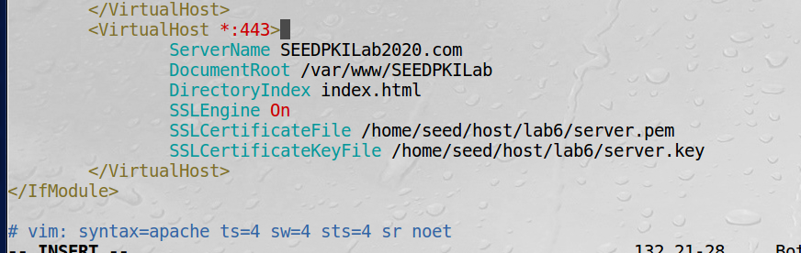

Then we have to create a simple website located at /var/www/SEEDPKILab:

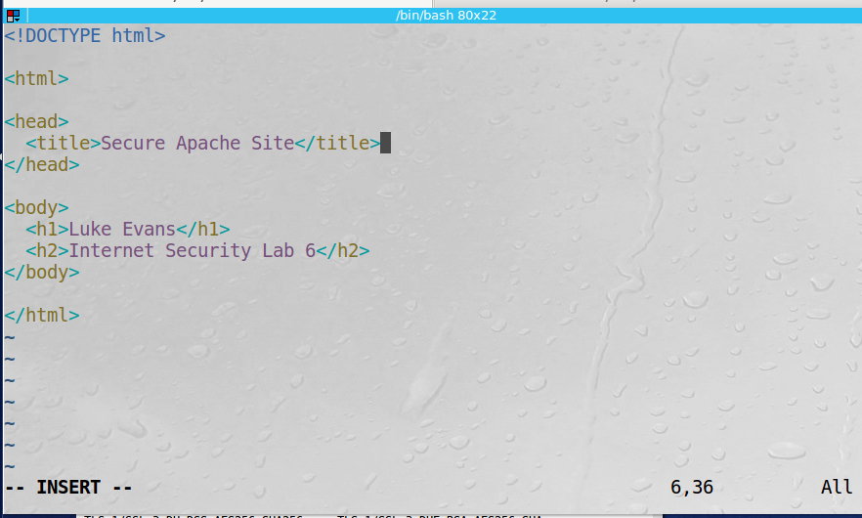

Finally, we run commands to test our configuration and restart the server:

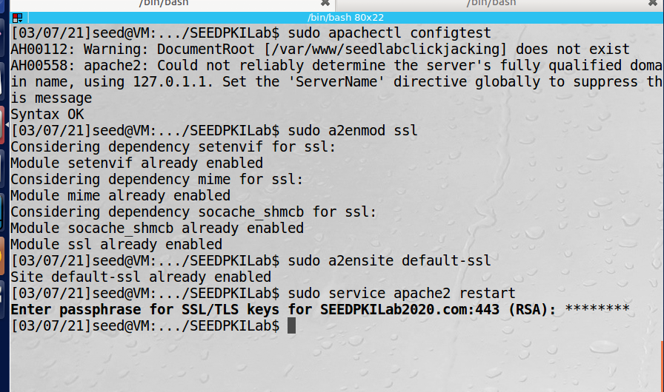

After restarting out apache server and navigating to the webpage we see the following:

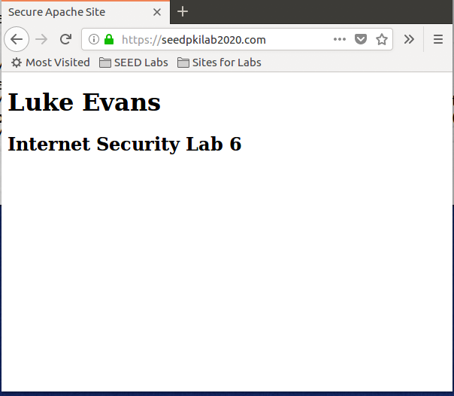

Observation: This task we similar to the previous task however this was more related to what you would do in a real server environment. We modified the appropriate apache config files and then ran the commands to load our certificates and restart the server.

Explanation: Apache is an easy to configure webserver. We were able to create a simple webpage, load our site, and configure our server in about 10 minutes.